

| **TITLE**: Design and render the object (Nature, Household, mechanical or other) |
| --- |

**AIM:**

Design and render the object (Nature, Household, mechanical or other)

Students Needs to check allotment from list of objects and design-render.(List is given on LMS)

**____________________________________________________________________**

**Expected OUTCOME of Experiment:**

Understand the computer Input & interaction, Curves and Computer Animation

**_____________________________________________________________________**

**Books/ Journals/ Websites referred:**

* google
* geeksforgeeks

**_____________________________________________________________________**

**Steps to perform:**

1. Get clear images of the McLaren F1 car from different angles.
2. Open Blender and import your reference images.
3. Begin with a basic shape like a cube. Modify it to match the car’s main body.
4. Create parts like the wheels and wings by adding more shapes and adjusting them.
5. Unwrap the car to apply textures. This makes the car look realistic.
6. Set up lights and a camera, then render your model to see how it looks.

**Drive or GitHub/google drive link:**

[**https://drive.google.com/file/d/1xiQUp_83vqYj4TxC3aEoip-wJh2rxet_/view?usp=drive_link**](https://drive.google.com/file/d/1xiQUp_83vqYj4TxC3aEoip-wJh2rxet_/view?usp=drive_link)

**Output(s) (Screen Shots):**

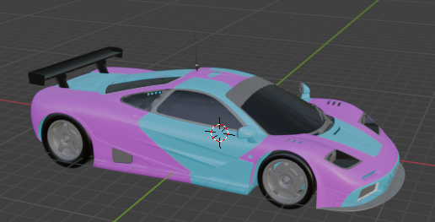

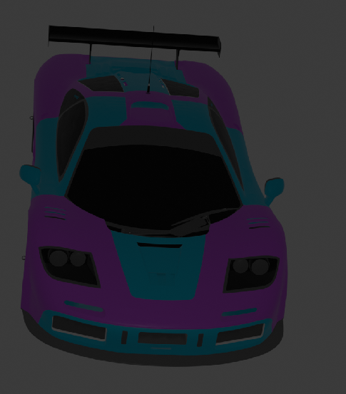

**Conclusion and discussion:**

**Used blender to make the 3d model.**

**Date: 8/10/24**

**Signature of faculty in-charge**